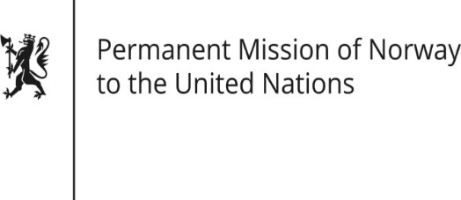

STATEMENT

Universal Periodic Review 37th session
Norway's statement during the 37th UPR session of the Human Rights Council on the human rights situation in Myanmar
as delivered by Ambassador Tine Mørch Smith,
Permanent Representative of Norway

25 January 2021

Check against delivery
Madam President,
Norway recommends that Myanmar:
1) ensures a safe environment for civil society, human rights defenders and journalists by amending legislation that limits freedom of expression
2) ensures the independence of the Myanmar National Human Rights Commission's by strengthening the MNHRC Law, including establishing criteria for appointment of gender-diverse commissioners
3) reforms laws and practices to confer citizenship and documentation based on clear and objective criteria, without discrimination on the basis of race, ethnicity and religion
4) amends the draft law on protection from violence against women to contain clear definitions of gender-based violence in line with international standards
5) ensures the rights to food and health for conflict-affected and internally displaced persons, including by allowing unrestricted access for humanitarian actors.

Thank you.

