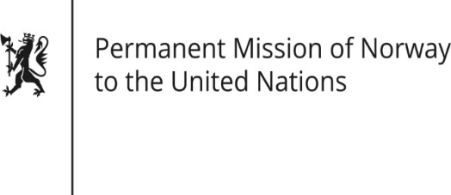

STATEMENT

Universal Periodic Review 37th session
Norway's statement during the 37th UPR session of the Human Rights Council on the human rights situation in Austria
as delivered by Ambassador Tine Mørch Smith,
Permanent Representative of Norway

22 January 2021

Check against delivery

Madam President,

Norway welcomes the positive steps taken since the last review, including measures taken to recognise and support victims of child trafficking, as well as progress made in women’s representation in leadership positions.

Norway also welcomes the initiatives Austria is taking to limit hate speech online. Norway remains concerned about the occurrence of, and the lack of comprehensive data collection on incidents of hate crimes and hate speech, as well as the shortage of staffing in prisons.

Norway recommends that Austria:

1) strengthens its systematic approach to prevent and combat hate speech and hate crimes, by following up on the recommendations of the European Commission against Racism and Intolerance (ECRI);

2) ensures an adequate staffing situation within the penitentiary system;

3) develops a national human rights action plan with concrete and measurable objectives ensuring meaningful participation of civil society.

Thank you.

