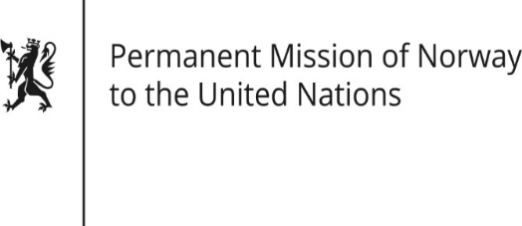

STATEMENT

Universal Periodic Review 37th session
Norway's statement during the 37th UPR session of the Human Rights Council on the human rights situation in Nepal
as delivered by Ambassador Tine Mørch Smith,
Permanent Representative of Norway

21 January 2021

Check against delivery
Madam President,
Norway [welcomes Nepal’s participation in the UPR process. We] congratulate[s] Nepal for being elected to the UN Human Rights Council 2021-23. [We commend Nepal’s efforts to create a constitutional framework that promotes equality and security for all. We commend Nepal for recently having acceded to the Palermo Protocol to Prevent, Suppress and Punish Trafficking in Persons, Especially Women and Children.]
[Norway remains concerned about conditions for children, women and disadvantaged minority groups, and the continued existence of practices such as bonded labour, trafficking in persons and child labor.]

Norway recommends that Nepal:
1) passes a bill to amend the Act on Commissions on Investigation of Disappeared Persons, Truth and Reconciliation in order to ensure effective functioning of the Commissions;
2) fully commits to end sexual and gender-based harassment and violence at all levels of society; including against LGBTI persons;
3) takes further steps to end trafficking in persons and bonded labour practices, with special emphasis on children;
4) continues its efforts to ensure an all-inclusive education system that leaves no-one behind, including children with disabilities;
5) removes restrictions on the right to freedom of religion or belief in the criminal code.

Thank you.

