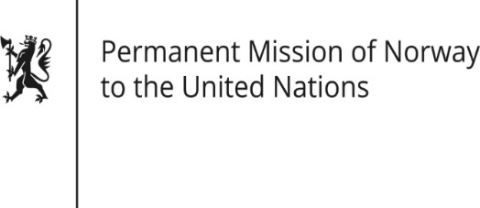

STATEMENT

Universal Periodic Review 37th session
Norway's statement during the 37th UPR session of the Human Rights Council on the human rights situation in Mauritania
as delivered by Ambassador Tine Mørch Smith,
Permanent Representative of Norway

19 January 2021

Check against delivery
Madam President,
Norway commends Mauritania’s first democratic transition in June 2019. Furthermore, Norway recognises the Mauritanian Government’s increased efforts to combat corruption.
While acknowledging recent convictions of slave masters, we recommend that further action be taken to combat slavery.
Norway recommends that Mauritania:
1) takes further action to identify and release people in slavery, and prosecute perpetrators;
2) takes further action to criminalise gender-based violence and female genital mutilation, including the strengthening and enforcement of the legal framework;
3) ratifies the Second Optional Protocol to the International Covenant on Civil and Political Rights, aiming at the abolition of death penalty;
4) decriminalize consensual same sex-relations between adults;
5) takes further action to fulfil children’s right to education, including children without civil registration documents and children with disabilities.
Thank you.

