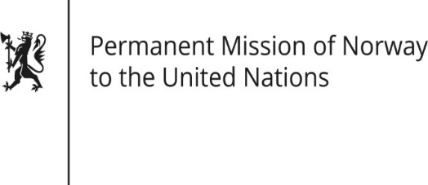

STATEMENT

Universal Periodic Review 37th session
Norway's statement during the 37th UPR session of the Human Rights Council on the human rights situation in Australia
as delivered by Ambassador Tine Mørch Smith,
Permanent Representative of Norway

20 January 2021

Check against delivery
Madam President,

Norway [welcomes Australia’s participation in the UPR process and] notes the positive steps that have been taken since the last review, including Australia’s progress on the transfer of asylum seekers away from the offshore process centres in Nauru and Papua New Guinea. Norway is concerned about asylum seekers remaining in Nauru and PNG, and about the number of asylum seekers still detained in Australia.
[Norway remains concerned that mandatory sentencing laws, which may disproportionately affect Aboriginal and Torres Strait Islander peoples, continue to exist in Australian jurisdictions. Norway is concerned about the low minimum age for criminal responsibility, which disproportionately affects Aboriginal and Torres Strait Islander children.]
Norway recommends that Australia:
1. ensures that asylum seekers’ claims are processed in accordance with the UN Refugee Convention and that detention only occurs when necessary and justified, for a minimum period of time, and subject to timely judicial oversight;
2. reviews mandatory sentencing laws with a view to abolishing them while expanding non-custodial measures where appropriate.
3. adopts recommendations by the UN [Committee on the Rights of the Child] (CRC) to raise the minimum age of criminal responsibility to at least 14 years of age.

Thank you.

