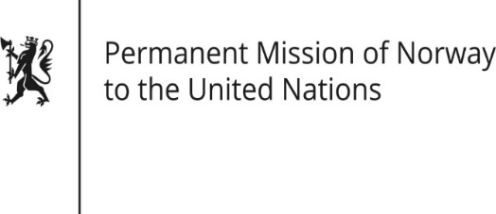

STATEMENT

Universal Periodic Review 37th session
Norway's statement during the 37th UPR session of the Human Rights Council on the human rights situation in Lebanon
as delivered by Ambassador Tine Mørch Smith,
Permanent Representative of Norway

18 January 2021

Check against delivery
Madam President,
Norway notes the positive steps Lebanon has taken against sexual harassment, domestic violence and towards an active National Preventive Mechanism against torture. We commend the passing of the Law for the Missing and Forcibly Disappeared Persons. We remain concerned about the slow implementation of both the mechanisms and the law.
Norway recommends that Lebanon:
1) approves and implements laws to strengthen the independence of judiciary in accordance with international standards.
2) lifts the reservation on Article 9 of the Convention on the Elimination of All Forms of Discrimination against Women and allows women to pass citizenship to their children and spouses.
3) strengthens the protection of rights and freedom of refugees, including by respecting non-refoulement obligations.
4) ends discrimination on the basis of sexual orientation and gender identity, including by repealing the Penal Code’s article 534.
5) ensures freedom of expression and assembly, and prevents violence against peaceful demonstrators.

Thank you.

