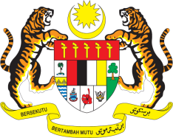

Statement by Malaysia
Review of Rwanda
37th Session of the UPR Working Group
18-29 January 2021

Malaysia thanks the delegation of Rwanda for the presentation of their national report which highlights the efforts made in implementing accepted recommendations from Rwanda’s Second UPR, as well as numerous initiatives to promote and protect human rights of all Rwandans.

- Malaysia welcomes the adoption of the first ever National Human Rights Action Plan in 2017 and calls for its effective and comprehensive implementation. Malaysia appreciates the Government’s efforts to address gender-based violence in the country through systematic and targeted programmes, which include Isange One Stop Centres, specialised units in government offices, as well as the community policing, anti-gender-based violence and child protection committees at the villages. We hope that the Gender Based Violence Management Information System (GBVIMS) will be launched soon to further consolidate and strengthen measures to address gender-based violence. Rwanda’s achievement in providing universal access to primary education is commendable and we hope further efforts will be made to ensure right to inclusive education for all Rwandans.

- In the spirit of constructive engagement, Malaysia recommends the following:

  - increase efforts to eradicate child labour;
  - adopt and implement comprehensive policies to increase the employment opportunities for persons with disabilities and take more measures to promote the integration of women into the labour force including through gender sensitive employment policy; and
  - provide families living in poverty with adequate social protection and create income-generating opportunities for them.

- Malaysia wishes Rwanda a successful review.

Thank you.

GENEVA
25 January 2021

