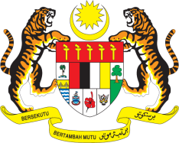

Statement by Ambassador Ahmad Faisal Muhamad
Review of Oman
37th Session of the UPR Working Group
18-29 January 2021

Malaysia thanks Oman for the presentation of its national report.

- Malaysia welcomes Oman’s progress in implementing UPR recommendations since its second review including its accession to three core human rights treaties.

- Malaysia welcomes the gender parity that has been achieved in the education sector and further welcomes the Government’s efforts to ensure inclusive education for all.

- In the spirit of constructive engagement, Malaysia recommends the following:

  - One: strengthen efforts to combat trafficking in persons including by intensifying investigations, prosecuting perpetrators and assist victims with adequate remedies;
  - Two: continue implementing programmes to raise human rights awareness including among enforcement authorities; and
  - Three: continue taking efforts to increase women representation in the workforce.

Malaysia wishes Oman a successful review.

Thank you.

GENEVA
21 January 2021

