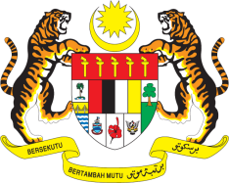

Statement by Ambassador Ahmad Faisal Muhamad
Review of Nepal
37th Session of the UPR Working Group
18-29 January 2021

Malaysia thanks Nepal for the presentation of its national report.

- Malaysia commends Nepal’s constructive engagement with the Human Rights Council and its mechanisms. We strongly commend Nepal’s relentless efforts to deliver a high quality of life for its people and promote human rights in the country.

- Malaysia welcomes the successful implementation of the Fourth National Human Rights Action Plan and look forward to an effective implementation of the recently adopted Fifth National Human Rights Action Plan.

- In the spirit of constructive engagement, we recommend the following:

  - increase efforts to prevent trafficking in persons, slavery, sexual exploitation and forced labour including child labour;
  - increase measures to ensure that persons with disabilities have access to community-based rehabilitation services and adequate social protection programmes; and
  - ensure sustainable funding for a sufficient number of safe shelters for victims of gender-based violence.

Malaysia wishes Nepal a successful review.

Thank you.

GENEVA
21 January 2021

