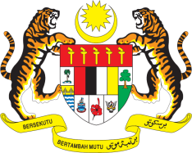

Statement by Malaysia
Review of Nauru
37th Session of the UPR Working Group
18-29 January 2021

Malaysia thanks the delegation of Nauru for the presentation of their national report.

- Malaysia welcomes Nauru’s commitment to human rights promotion and protections and efforts in ensuring the human rights of its citizens are respected. Noting the critical importance of ensuring adequate and effective institutional human rights frameworks in the country, Malaysia recommends that Nauru establishes a National Human Rights Institution, in accordance with the Paris Principles.

- Malaysia also welcomes positive steps made on the promotion of women in decision making and leadership roles as well as the adoption of Domestic Violence and Family Protection Act in 2017. We further welcome efforts to strengthen the National Plan of Action for Women and laud the hosting of the first Nauru National Women’s Summit that was held in 2019, which testifies the Government’s firm commitment to advance women’ rights in the country. Malaysia recommends that Nauru continues its efforts to promote and safeguard women’ rights and their wellbeing in the country including by ensuring access to mental health services for women.

- Malaysia lauds Nauru’s strong commitment to tackle climate change. We recommend that Nauru continues to undertake robust measures and call for its initiatives to be inclusive and caters to the needs of vulnerable groups.

- Malaysia wishes Nauru a successful review.

Thank you.

GENEVA
27 January 2021

