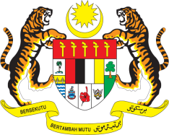

Statement by Ambassador Ahmad Faisal Muhamad
Review of Myanmar
37th Session of the UPR Working Group
18-29 January 2021

Malaysia thanks Myanmar for the presentation of its national report.

- Malaysia notes Myanmar’s efforts to advance socio-economic development and improve its human rights situation. Indeed, genuine and sustainable processes of democratization and reconciliation are crucial. Malaysia will continue to be a constructive partner to Myanmar.

- Myanmar has made notable progress since its Second UPR. In the spirit of constructive engagement, we wish to make the following recommendations:

  - One: continue to implement measures to curb discrimination, violence and other human rights violations against minorities;
  - Two: continue to provide equal access to education for all;
  - Three: sustain and strengthen efforts towards restoring peace and stability, as well as promote inclusive development in Rakhine; and
  - Four: cooperate with all relevant partners, regional and international human rights mechanisms to address the persisting human rights and humanitarian situation in Rakhine.

- Malaysia wishes Myanmar every success in its Third UPR.

Thank you.

GENEVA
25 January 2021

