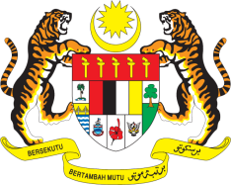

Statement by Malaysia
Review of Mauritania
37th Session of the UPR Working Group
18-29 January 2021

Malaysia thanks the distinguished delegation of Mauritania for the presentations of their national report. We are pleased to note that the Government had conducted consultation with civil society in its preparation.

- Malaysia takes note of the numerous legislative reforms undertaken since Mauritania’s Second UPR including a review of the law to combat violence against women and girls. We look forward to its swift adoption by the National Assembly and effective implementation subsequently.

- In the spirit of constructive engagement in the framework of Mauritania’s Third UPR, my delegation recommends the following:

  - ensure the effective implementation of the Trafficking in Persons Act, including by promoting the reporting of child trafficking incidents;

  - incorporate a comprehensive child rights perspective into action plan on combating trafficking in persons with a view to developing further prevention, protection and prosecution measures to combat the sexual and labour exploitation, sale, abduction of, and trafficking in children; and

  - enhance efforts to increase the quality of education, including by providing training to teachers, constructing and improving educational facilities and schools, particularly in rural areas.

- Malaysia wishes Mauritania a successful review.

Thank you.

GENEVA
19 January 2021

