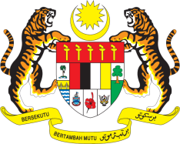

Statement by Ambassador Ahmad Faisal Muhamad
Review of Lebanon
37th Session of the UPR Working Group
18-29 January 2021

Malaysia thanks the distinguished delegation of Lebanon for the presentation of their national report.

- Malaysia welcomes the Government driven ‘whole of society’ commitment to implement recommendations from its last UPR cycle. It is commendable that Lebanon has implemented a nationwide programme against the exploitation of street children.

- Malaysia also welcomes the Strategic Plan for the Protection of Women and Children and encourages the Government to undertake a robust and targeted approach in its implementation. In the spirit of constructive engagement, my delegation recommends the following:

  - One: Tackle unemployment, especially among young people and women;

  - Two: Ensure access to safe drinking water and sanitation to all; and

  - Three: Allocate adequate resources to ensure rehabilitative services to street children, and enforce legislation to address child labour.

- Malaysia wishes Lebanon a successful review and we stand in solidarity with the Government as it recovers from the humanitarian tragedy of August 2020.

Thank you.

GENEVA
18 January 2021

