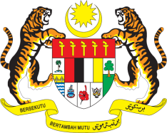

Statement by Malaysia
Review of Georgia
37th Session of the UPR Working Group
18-29 January 2021

Malaysia thanks the distinguished delegation of Georgia for the presentation of their national report.

- Malaysia commends Georgia’s constructive engagement in the UPR process and progress made in terms of the implementation of accepted recommendations from its Second UPR. We take note of the Government’s sustained efforts to put in place legislative and institutional human rights framework to further promote human rights in the country. In this context, Malaysia looks forward to Georgia’s second human rights strategy and the fourth human rights action plan.

- In the spirit of constructive engagement within the framework of Georgia’s Third UPR, my delegation recommends the following:

  - continue taking measures to ensure that victims of trafficking are provided with appropriate protection, legal services and remedies; and

  - intensify efforts to ensure full enjoyment of economic, social and cultural rights particularly by ethnic minorities including in areas relating to education and employment.

- Malaysia wishes Georgia a successful review.

Thank you.

GENEVA
26 January 2021

