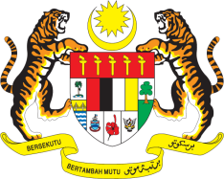

Statement by Malaysia
Review of Federated States of Micronesia
37th Session of the UPR Working Group
18-29 January 2021

Malaysia thanks the delegation of Micronesia for the presentation of their national report.

- Malaysia welcomes the various policies and programmes that the Government had developed to further promote human rights in the country. Malaysia hopes that the implementation of the National Strategic Development Plan, National Gender Policy, Disability Policy, and National Youth Policy among others, would continue to safeguard the well-being and human rights of its people. Malaysia further hopes that the Government will continue to tackle challenges related to climate change, which also greatly influence realization of the human rights of its people.

- In the spirit of constructive engagement within Micronesia’s Third UPR, Malaysia recommends the following:

  - implement a comprehensive social protection system to further assist vulnerable groups and individuals, in particular those in the informal sector;
  - tackle neonatal death by implementing high quality and affordable antenatal and maternal care as well as community based care for mothers and new-borns;
  - expand the availability and accessibility of affordable services for people living with HIV and other sexually transmitted infections; and
  - promote right to education by ensuring primary education is compulsory and fully available as well accessible for all.

- Noting the challenges that the Government continue to face in fulfilling its human rights obligations, we encourage Micronesia to continue to draw on international assistance particularly in capacity building and technical cooperation

- Malaysia wishes Micronesia a successful review.

Thank you.

GENEVA
18 January 2021

