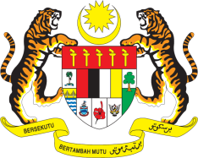

Statement by Ambassador Ahmad Faisal Muhamad
Review of Austria
37th Session of the UPR Working Group
18-29 January 2021

Malaysia thanks Austria for the presentation of its national report.

- Malaysia welcomes Austria’s constructive engagement with the Human Rights Council and its mechanisms.

- While acknowledging the progress made in the protection of minorities, further improvements can be made. In this regard, Malaysia recommends that the Government strengthen the implementation of its programmes and undertake necessary legal reforms to address the issue.

- Malaysia welcomes the amendment to the Social Security Act and recommends that the Government take further measures to reduce poverty among older persons, particularly older women and older migrants. Also, while Malaysia commends Austria’s efforts to improve the rights of persons with disabilities, we urge the Government to curb discrimination persistently faced by women and girls with disabilities.

Malaysia wishes Austria every success in its Third UPR.

Thank you.

GENEVA
22 January 2021

