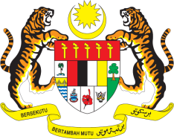

Statement by Ambassador Ahmad Faisal Muhamad
Review of Australia
37th Session of the UPR Working Group
18-29 January 2021

Malaysia thanks Australia for the presentation of its national report.

- Malaysia welcomes Australia’s commitment to fulfil its human rights obligations since its last UPR. Malaysia commends among others, the National Plan to Reduce Violence against Women, which aims to reduce family, domestic and sexual violence.

- However, improvements could still be made particularly in tackling cases of violence among indigenous women and women with disabilities. Malaysia recommends that Australia further strengthen its policies and allocate adequate resources to address sexual and gender-based violence.

- Malaysia notes Australia’s efforts to ensure rights of minorities. We recommend that the Government continue to address inequalities faced by minorities. Further we also recommend that Australia strengthen measures to address racial discrimination, xenophobia and prejudices against members of religious and ethnic minorities.

Malaysia wishes Australia a successful review.

Thank you.

GENEVA
20 January 2021

