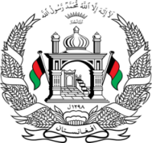
Permanent Mission of Islamic Republic of Afghanistan
37th Session of the UPR Working Group

Statement on the Review of Georgia

26 January 2021 at 9:00

Mr./Mme. (Vice) President,

Afghanistan warmly welcomes the distinguished Georgian delegation to this meeting. We commend the positive developments since the previous cycle that contributed to progress in the promotion and protection of human rights in the country.

Afghanistan welcomes the adoption of the Law on the State Inspector Service in 2018 and the work carried out to improve the Law on Conflicts of Interest and Corruption in Public Institutions.

Mr./Mme. (Vice) President,

In the spirit of constructive engagement, we wish to make the following recommendations:

- Increase efforts to combat discrimination by combating stigma and hate speech through human rights education and awareness-raising.

- Ensure that all persons in need of international protection have access to a fair and efficient asylum procedure free of charge and that the decision not to grant asylum is properly justified and was communicated to the concerned individuals.

Finally, Afghanistan wishes Georgia every success in the UPR review process.

I thank you, Mr. /Mme. (Vice) President.

