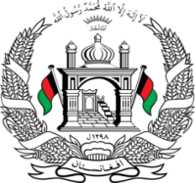
Permanent Mission of Islamic Republic of Afghanistan
37th Session of the UPR Working Group

Statement on the Review of Myanmar

25 January 2021 at 9:00

Mr./Mme. (Vice) President,

Afghanistan cordially welcomes the delegation of Myanmar and thanks them for the engagement with the UPR and the Council.

We welcome the launch of the national strategy on resettlement of internally displaced persons and closure of camps for the IDPs, in 2019.

My delegation recommends Myanmar to:

Grant access to the UN and NGOs, to provide humanitarian assistance in Rakhine State.

Enable the IDPs to return to their places of origin or choice.

Cooperate with the UN human rights mechanisms, and the ICJ, complying with its interim order.

Enact an anti-discrimination law and revise laws and policies that perpetuate discrimination based on ethnicity and religion, in particular, the citizenship law.

Take practical steps to register Rohingya children, providing them with birth certificates, and assuring their right to nationality.

Finally, Afghanistan wishes Myanmar every success in the UPR review process and the implementation phase.

I thank you!

