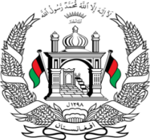
Permanent Mission of Islamic Republic of Afghanistan
37th Session of the UPR Working Group

Statement on the Review of Oman

21 January 2021 at 14:30

Mr./Mme. (Vice) President,

Afghanistan cordially welcomes the distinguished delegation of the Sultanate of Oman. We express our appreciation for their engagement with the UPR and for their positive progress since the last UPR cycle.

Afghanistan recognizes the withdrawal of the reservations relating to Articles 7, 9, 21 and 30 of the Convention on the Rights of the Child and the adoption of the Child Act, which prohibits any form of violence against children.

Afghanistan remains concerned about the absence of legislation or administrative regulations governing the status of asylum seekers or refugees.

Mr./Mme. (Vice) President,

In the spirit of constructive engagement, we wish to make the following recommendations:

- Adopt national asylum legislation in line with international standards and provide safeguards against refoulement.

- Strengthen awareness-raising and education programs and formulate a comprehensive strategy for preventing and combating child abuse in all settings.

Finally, Afghanistan encourages Oman to continue to promote and protect human rights in the context of COVID-19 and wishes Oman every success in the UPR review process.

I thank you, Mr./Mme. (Vice) President.

