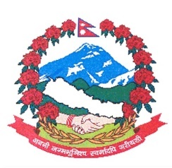
Statement by the delegation of Nepal
37th session of the Working Group on the Universal Periodic Review
UPR of Saint Lucia
20 January 2021

Time: 1 min 50 secs
Words: 205

Madam President

Nepal warmly welcomes the delegation of Saint Lucia to the third cycle of UPR and appreciates its commitment to the universal protection and promotion of human rights.

Nepal appreciates Saint Lucia’s multisectoral approach in combatting Gender Based Violence. We commend Saint Lucia’s Essential Services Programme that trains individuals within various communities to provide support to victims and persons at risk of domestic violence.

We are encouraged by National Plan/Partnership of Action (NPA) to end gender-based violence in Saint Lucia. Saint Lucia’s strategies aimed at preventing violence against women and girls, in primary and secondary schools are noteworthy.

Madam President,

Noting that Saint Lucia as a Small Island Developing State is vulnerable to climate change, we appreciate that climate change is taken into consideration in its development agenda. We are concerned that the climate change could further exacerbate the vulnerabilities faced by its vulnerable and marginalized groups, including women, children, persons with disabilities, older persons and others.

While wishing Saint Lucia a successful review, we recommend the following for their consideration:

- Take necessary measures to prevent, punish and eradicate all forms of violence against women.
- Continue to develop and implement successful climate change mitigation and adaptation policies and practices.

Thank you.

