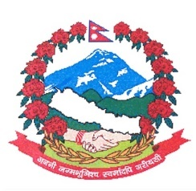
Statement by the delegation of Nepal
37th session of the Working Group on the Universal Periodic Review
UPR of Lebanon
18 January 2021

Time: 1 min 5 secs
Words: 138

Madam President

Nepal warmly welcomes the delegation of Lebanon to the third cycle of UPR and appreciates its commitments for the universal protection and promotion of human rights.

Nepal appreciates the continuation of moratorium on death penalty in Lebanon.

We also take note of the measures taken by Lebanon towards the protection of migrant labour including domestic labour.

We commend the efforts made by Lebanon to increase participation of women in local government and development.

While wishing Lebanon a successful review, we recommend the following for their consideration:

- Take necessary measures to ensure that effective protection against discrimination in all aspects of their employment is provided to all migrant domestic workers.
- Continue necessary efforts to empower women economically, politically and socially, and take all necessary measures to eliminate all forms of discrimination against women.
Thank you.

