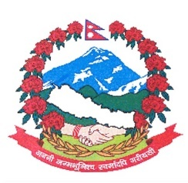
Statement by the delegation of Nepal
37th session of the Working Group on the Universal Periodic Review
UPR of Australia
20 January 2021

Time: 55 secs
Words: 113

Madam President

Nepal warmly welcomes the delegation of Australia to the third cycle of UPR.

Nepal appreciates Australia’s focus on providing resettlement for vulnerable population, including women, children, and LGBTIQ+, at humanitarian risk.

We also take note of Australia’s efforts to reduce the disparity in economic, health and education outcomes between Indigenous and non-Indigenous populations.

While wishing Australia a successful review, we recommend the following for their consideration:

- Continue efforts towards addressing discrimination against minorities and indigenous people to achieve equality for all in society.
- Continue to review and assess its immigration laws and policies to ensure that the rights of migrants are safeguarded, in accordance with international human rights standards.
Thank you.

