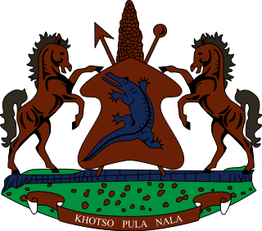

STATEMENT BY THE KINGDOM OF LESOTHO DURING THE 3rd UPR REVIEW OF MAURITANIA

19 JANUARY, 2021

Thank you Madam President,
Lesotho extends a warm welcome to the delegation of Mauritania, as it undertakes the 3rd cycle of the UPR, amidst this difficult times of the Covid-19 pandemic. We applaud Mauritania for having ratified a number of ILO Conventions such as those on international labour standards, migrants workers and social security. We further appreciate the steps taken to address overcrowding in prisons by building new facilities and refurbishing existing ones.

In the spirit of cooperation and constructive approach, we wish to make the following three recommendations for consideration by the delegation of Mauritania: 1. Continue efforts to protect women and children against human trafficking; 2. To continue to allocate funds for the development of inclusive education, including for children of irregular migrants; 3. Strengthen cooperation with international and regional human rights protection mechanisms, in particular with the UN special procedures mandate holders, as well as with the African Commission on Human and Peoples' Rights.

We wish Mauritania every success with this UPR cycle.
I thank you Madam President.

