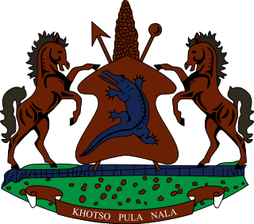

STATEMENT BY THE KINGDOM OF LESOTHO DURING THE 3rd UPR REVIEW OF NAURU

27 JANUARY, 2021

Thank you, Madam President,

Lesotho extends a warm welcome to the delegation of Nauru to the Working Group and thank them for the presentation of their National Report. We note the steps taken by Nauru to safeguard the right to education of children by providing free primary and secondary education. We further applaud Nauru for enacting the Environmental Management and Climate Change Act of 2020 and for establishing the Department of Climate Change and National Resilience, with deals specifically with climate change. These measures will go a long way in confronting the issues pertaining to climate change in the Island.

Notwithstanding the positive and commendable steps to protect and promote human rights of its people, we wish to make the following three recommendations for consideration by the delegation of Nauru: 1. To ratify the Convention on the Rights of Migrant Workers and the Convention on Enforced Disappearance; 2. To beef up measures to fight domestic and sexual violence against women and girls; and 3. To continue to improve measures to safeguard the rights of refugees and asylum seekers and to raise public awareness of refugee and asylum seeker issues .

We wish Nauru every success with this UPR cycle.

I thank you Madam President.

