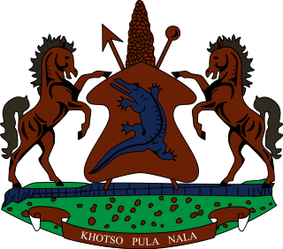

STATEMENT BY THE KINGDOM OF LESOTHO DURING THE 3rd UPR REVIEW OF RWANDA

25 JANUARY, 2021

Thank you Madam President,
Lesotho extends a warm welcome to the delegation of Rwanda, as it undertakes the 3rd cycle of its UPR Review. We applaud Rwanda for honouring its reporting obligations by submitting national reports under the Convention Against Torture, CRC, ICESCR and the Convention on the Rights of Migrant Workers.

In the spirit of cooperation and constructive approach, we wish to make the following two recommendations to the delegation of Rwanda: 1. Continue efforts to promote and protect the rights of refugees, in particular their right to food, education and access to clean and safe drinking water; 2. to strengthen measures to eliminate sexual and gender based violence against adolescent girls and women.

We wish Rwanda every success with this UPR cycle.
I thank you Madam President.

