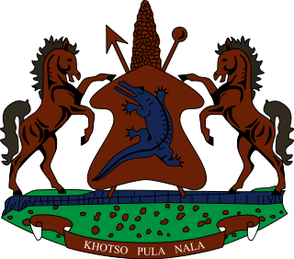

STATEMENT BY THE KINGDOM OF LESOTHO DURING THE 3rd UPR REVIEW OF MYANMAR

25 JANUARY, 2021

Thank you, Madam President,
Lesotho extends a warm welcome to the delegation of Myanmar to the Working Group and thank them for the presentation of their National Report. We applaud Myanmar for ratifying the International Covenant on Economic, Social and Cultural Rights (ICESCR) in 2017 and for establishing the Human Rights Commission is in line with the Paris Principles.

In the spirit of cooperation and constructive approach, which forms the premise of this process, we wish to make the following three recommendations for consideration by the delegation of Myanmar: 1. To undertake measures to accord the Rohinga community their rights to equality, nationality, access to adequate healthcare and education; 2. Strengthen cooperation with international human rights protection mechanisms, in particular, extend standing invitations to UN special procedures mandate holders; and 3. To ratify the Convention against Torture and ICCPR.
We wish Myanmar every success with this UPR cycle.
I thank you Madam President.

