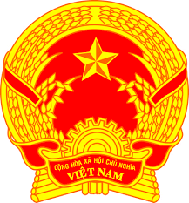
STATEMENT OF VIETNAM
At the 37th Session of the UPR Working Group
Review of Oman
(Thursday, 21 January 2021)

Madam President,
Viet Nam is pleased to welcome and thank the delegation of Oman for the comprehensive presentation of the national UPR report.
Viet Nam welcomes the progress made by Oman regarding the legislative development and initiatives in promoting and protecting the human rights of its people.
In a spirit of constructive dialogue, Viet Nam would like to make the following recommendations to Oman:
1. Continue its efforts to further promote the rights of women, children and persons with disabilities;
2. Continue its efforts to promote and protect the rights of workers, in particular, foreign workers by taking further necessary institutional and legislative steps in this field.
Viet Nam wishes Oman a successful review.
Thank you, Madam President./.

