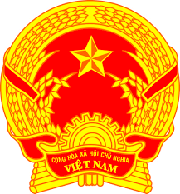
STATEMENT OF VIETNAM
At the 37th Session of the UPR Working Group
Review of Nepal
(Thursday, 21 January 2021)

Madam President,
Viet Nam is pleased to welcome and thank the delegation of Nepal for the comprehensive presentation of the national UPR report.
Viet Nam commends the progress made by Nepal regarding building necessary legal, policy and institutional foundations for the promotion and protection of human rights of its people.
In a spirit of constructive dialogue, Viet Nam would like to make the following recommendations to Nepal:
1. Continue to strengthen its efforts in implementing the Sustainable Development Goals for the better enjoyment of human rights of its people;
2. Continue its efforts to eliminate forms of discrimination against women and girls, and further promote the rights of women, children and persons from other vulnerable groups.
Viet Nam wishes Nepal a successful review.
Thank you, Madam President./.

