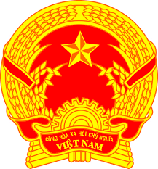
Statement of the Socialist Republic of Viet Nam
At the 37th Session of the UPR Working Group
Review of Georgia
(Geneva, 26 January 2021, 9:00-12:30)

Mister/Madam President,
Viet Nam is pleased to welcome and thank the delegation of Georgia for the comprehensive presentation of the national UPR report.
Viet Nam takes good note of significant achievements made by the Government of Georgia in legislative and policy reform, including new laws on anti-discrimination, juvenile justice, occupational safety, child rights and the protection of migrants and asylum seekers.
In a spirit of constructive dialogue, Viet Nam would like to make the following recommendations to Georgia:
1. Continue to develop the second Human Rights Strategy and implement the fourth Human Rights Action Plan to ensure everyday protection of human rights in Georgia.
2. Better ensure equal and full participation of ethnic minorities in civic and political life and protect their cultural identity.
We wish the delegation of Georgia a successful outcome of the review.
Thank you, Madam/Mister President./.

