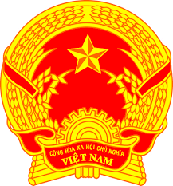
Statement of the Socialist Republic of Viet Nam
At the 37th Session of the UPR Working Group
Review of Austria
(Geneva, 22 January 2021, 9:00-12:30)

Delivered by
Mr. Quang Binh LE, Permanent Mission of the S.R. of Viet Na​​m to the United Nations, the World Trade Organization and o​ther International Organizations in Geneva, Switzerland

Madam President,
Viet Nam thanks Austria for its report and commends Austria’s strong human rights record. Viet Nam welcomes Austria’s commitment to human rights and its long-standing priorities on the rights of women, children, persons with disabilities, the rule of law, human rights education, and combatting racism and discrimination.
In a constructive spirit, Viet Nam recommends the following to Austria:
- Continue to pay special attention to combating poverty and social exclusion of children in Austria;
- Better enforce human rights compliance by private economic actors with a view to reducing the gender pay gap and diversifying career options for all.
In closing, Viet Nam wishes Austria every success in this UPR review.
I thank you, Madam President./.

