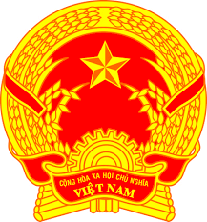
Statement of H.E. Ms. LE Thi Tuyet Mai,
Ambassador Extraordinary and Plenipotentiary
Permanent Representative of Viet Nam
to the United Nations Office in Geneva
At the 37th Session of the UPR Working Group
Review of Lebanon
(Monday, 18 January 2021)

Madam President,
Viet Nam is pleased to welcome and thank the delegation of Lebanon for the comprehensive presentation of the national UPR report.
Viet Nam welcomes Lebanon’s efforts in the implementation of the recommendations accepted under the 2nd UPR cycle and Viet Nam takes a good note of the measures put in place to promote gender equality, rights of women, children, persons with disabilities and persons from other vulnerable groups.
In the spirit of constructive dialogue, Viet Nam would like to recommend Lebanon to continue its efforts to overcome the current and emerging challenges in order to further promote the enjoyment of human rights of its people, especially the rights of women, children and persons from other vulnerable groups.
Viet Nam wishes Lebanon a successful review.
Thank you, Madam President./.

