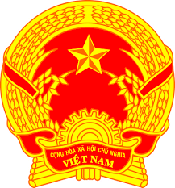
Statement of the Socialist Republic of Viet Nam
At the 37th Session of the UPR Working Group
Review of Myanmar
(Geneva, 25 January 2021, 9:00-12:30)

Delivered by
Mr. LE Quang Binh, Permanent Mission of the S.R. of Viet Na​​m to the
United Nations, the World Trade Organization and o​ther International Organizations in Geneva

Madam President,
Viet Nam welcomes Myanmar’s constructive engagement with the UPR process and thanks Myanmar for accepting Viet Nam's recommendations during its second cycle UPR.
We commend the efforts of the Government of Myanmar in the promotion and protection of the rights of its people, strengthening democratic institutions and fostering national reconciliation.
On this occasion, my delegation has two recommendations for Myanmar:
1. Continue to improve the rights and social welfare for persons belonging to minorities.
2. Promote more equitable socio-economic development in all states and regions within Myanmar in line with the National Constitution.
As a fellow member of ASEAN, Viet Nam would like to offer our best wishes to Myanmar in this UPR cycle.
Thank you, Madam President./.

