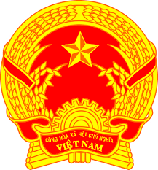
Statement of the Socialist Republic of Viet Nam
At the 37th Session of the UPR Working Group
Review of Australia
(Geneva, 20 January 2021, 9:00-12:30)

Delivered by
Mr. Quang Binh LE, Permanent Mission of the S.R. of Viet Na​​m to the United Nations, the World Trade Organization and o​ther International Organizations in Geneva, Switzerland

Madam President,
Viet Nam welcomes the delegation of Australia and notes encouraging developments in Australia since its last UPR.
We commend Australia for its very active role in this Council and its strong commitment to multiculturalism, diversity and social inclusion.
In a spirit of constructive dialogue, Viet Nam recommends that Australia:
(i) Ensure better pay equity and economic security for women;
(ii) Continue to improve education and health outcomes for people with unique vulnerabilities.
Finally, Viet Nam wishes the Australian delegation a successful review.
I thank you, Madam President./.

