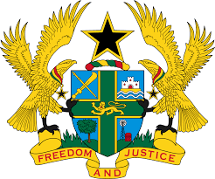

STATEMENT BY GHANA DELIVERED BY H.E RAMSES JOSEPH CLELAND,
AMBASSADOR AND PERMANENT REPRESENTATIVE,
THURSDAY 21ST JANUARY 2021

REVIEW OF SAINT LUCIA
Thank you, Madam President,
Ghana extends a warm welcome to the delegation of Saint Lucia to the UPR Working Group.
We commend Saint Lucia for accepting recommendations to ratify UNCAT, and would wish to know what steps the government has taken in pursuit of this objective. We also welcome the adoption of various domestic legislation such as the Education Sector Development Plan (ESDP) 2015-2020, Child Justice Act and the Children Care, Protection and Adoption Bill which were all passed recently. Lastly, we commend the establishment of the National Coordinating Committee for Human Rights, mandated to monitor and report on the national human rights national situation in the country.

In addition to the ratification of outstanding treaties, we wish to make the following other recommendations:
- Consider the establishment and implementation of training programmes to include the appropriate use of force by the security forces in the country; and finally

- Consider efforts to improve its judicial services by ensuring adequate protection for witnesses. To conclude, Ghana wishes Saint Lucia every success with the review process.

I thank you.

