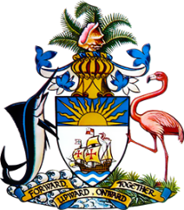

Statement by Ms. Sasha Dixon, Second Secretary
Permanent Mission of The Bahamas to the United Nations Office and Other International Organizations in Geneva
at the 37thSession of the Universal Periodic Review Working Group
Presentation of National Report by the Government of São Tomé and Príncipe
Wednesday, 27 January, 2021

Thank you, Madam/Mr.[Vice] President.
The Bahamas extends a warm welcome to the delegation of
São Tomé and Príncipe, thanks the country for its report and commends the engagement in this UPR process.
In a constructive spirit, The Bahamas recommends that
São Tomé and Príncipe:

- Provide at least twelve (12) years of free primary and secondary education of which at least nine (9) are compulsory, in accordance with Sustainable Development Goal 4
- Bring into full operation the national Commission for the Coordination of Implementation of the National Child Protection Policy;
and
- Continue to implement and provide adequate resources to the national Social Protective Strategy, which aims to contribute to the elimination of extreme poverty over the next 10 years.

As a fellow Small Island Developing State (SIDS), we recognise the challenges faced by São Tomé and Príncipe, including due to limited human and financial resources, as well as the disproportionate threats posed by climate change.

We therefore encourage São Tomé and Príncipe to avail itself of technical assistance and capacity-building support, in accordance with its human rights priorities and call on the international community to cooperate with the country in this regard.

We wish São Tomé and Príncipe every success in this UPR process.

I thank you.

