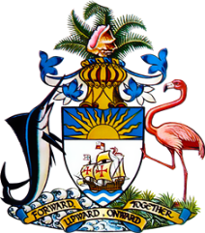
Statement by Ms. Sasha Dixon, Second Secretary
Permanent Mission of The Bahamas to the United Nations Office and Other International Organizations in Geneva
at the 37thSession of the Universal Periodic Review Working Group
Presentation of National Report by the Government of Nauru
Wednesday, 27 January, 2021

Thank you, Madam/Mr.[Vice] President.
The Bahamas extends a warm welcome to the delegation of Nauru, thanks the country for its report and commends the engagement in this UPR process.
In a constructive spirit, The Bahamas recommends that Nauru:

- Advance efforts toward adoption of the draft Human Rights Commission Bill which seeks to provide for the establishment of a National Human Rights Commission;
- Accelerate efforts, by the Nauru Rehabilitation Corporation (NRC), to institute safer, habitable places for relocation of Nauruans living in high-risk zones, due to phosphate mining;
and
- Seek technical assistance and capacity-building support to further strengthen protection and promotion of the rights of persons with disabilities.

As a fellow Small Island Developing State (SIDS), we recognise the challenges faced by Nauru, including due to limited human and financial resources as well as the disproportionate threats posed by climate change.

We therefore encourage Nauru to avail itself of technical assistance and capacity-building support, in accordance with its human rights priorities and call on the international community to cooperate with the country in this regard.

We wish Nauru every success in this UPR process.

I thank you.

