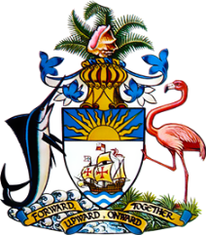

Statement by Ms. Sasha Dixon, Second Secretary
Permanent Mission of The Bahamas to the United Nations Office and Other International Organizations in Geneva
at the 37th Session of the Universal Periodic Review Working Group
Presentation of National Report by the Government of Rwanda
25th January, 2021

Thank you, Madam/Mr. [Vice] President.
The Bahamas extends a warm welcome to the delegation of Rwanda and thanks the country for its report.
We welcome the commitment of Rwanda to ensure that every Rwandan enjoys the fundamental human rights secured by the Constitution and other national and international human rights instruments. In this regard, we commend Rwanda for revising its Constitution and dedicating an entire chapter to human rights and freedoms.

We further recognise achievements in the area of legislative reform, including the adoption of a revised Penal Code, Code of Criminal Procedure and counter-terrorism legislation.

In a constructive spirit, The Bahamas recommends that Rwanda:

- commence a widespread educational campaign on the importance of antenatal care for pregnant women;
- Accelerate the scaling up of access to safe drinking water in schools, particularly at nursery, primary and secondary school level; and
- Fully implement plans to strengthen the school feeding programme that aims to reduce malnutrition among school-going children.

We wish Rwanda every success in this UPR process.

I thank you.

