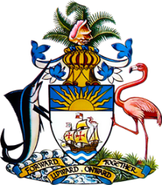

Statement by Ms. Sasha Dixon, Second Secretary
Permanent Mission of The Bahamas to the United Nations Office and Other International Organizations in Geneva
at the 37th Session of the Universal Periodic Review Working Group
Presentation of National Report by the Government of Austria
22nd January, 2021

Thank you, Madam/Mr. [Vice] President.
The Bahamas extends a warm welcome to the delegation of Austria and thanks the country for its report.
We recognise the commitment of Austria to promote and protect human rights and particularly
commend the country for implementing the Protection against Violence Act, which is intended to improve the protection of survivors of sexual violence and strengthen cooperation between relevant institutions.

We further welcome the efforts of Austria to protect the rights persons with disabilities, including the amendment of the Employment of People with Disabilities Act.

In a constructive spirit, The Bahamas recommends that Austria:

- establish an independent mechanism to investigate cases of ill-treatment and excessive use of force by law enforcement officials;
- take concrete steps to promote inclusive education for children with disabilities in the mainstream school system; and
- adopt a comprehensive strategy to eliminate discriminatory stereotypes regarding the roles and responsibilities of women and men in the family and in society.

We wish Austria every success in this UPR process.

I thank you.

