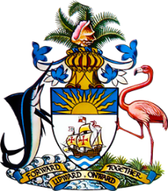

Statement by Ms. Sasha Dixon, Second Secretary
Permanent Mission of The Bahamas to the United Nations Office and Other International Organizations in Geneva
at the 37th Session of the Universal Periodic Review Working Group
Presentation of National Report by the Government of Nepal
18th January, 2021

Thank you, Madam/Mr. [Vice] President.
The Bahamas extends a warm welcome to the delegation of Nepal and thanks the country for its report and updates provided.
We commend the commitment of Nepal to promote and protect the human rights of all persons residing in the country and, in particular, congratulate Nepal on significant investments made to reduce poverty and improve standards of living.
We further welcome the efforts of Nepal in the area of climate change, particularly the implementation of the Disaster Management Act, 2018.
In a constructive spirit, The Bahamas submits the following recommendations to Nepal:

- Conduct public awareness campaigns to eliminate discrimination based on racial or caste-based hierarchies and ensure that educational curricula do not propagate these hierarchies;
- remove the one-year statute of limitation for rape and sexual violence to ensure that cases are brought to justice; and
- Fully enforce law and strengthen policy measures with a view to eliminating harmful traditional practices
We wish Nepal every success in this UPR process.

I thank you.

