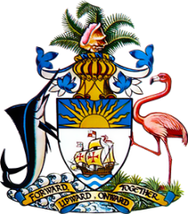

Statement by Ms. Sasha Dixon,
Permanent Mission of The Bahamas to the United Nations Office and Other International Organizations in Geneva
at the 37th Session of the Universal Periodic Review Working Group
Presentation of National Report by the Government of Australia
Wednesday 20th January, 2021

Thank you, Madam/Mr. [Vice] President.
The Bahamas thanks the delegation of Australia for the presentation of the national report and the updates provided today.
We commend Australia for strides made toward fostering a fairer and more inclusive society. We particularly acknowledge strengthened anti-trafficking measures and wide-ranging fiscal policies in support of vulnerable populations impacted by the COVID-19 pandemic.
In a constructive sprit, The Bahamas recommends that Australia:

- Take concrete steps to address the overrepresentation of indigenous peoples in the criminal justice system and the high rate of incarceration among them;
- Ensure that cashless debit and income management schemes are non-discriminatory in design and implementation, particularly for indigenous populations and
- Adequately fund the ‘National Plan to Reduce Violence Against Women and Their Children’ and ensure that the Plan is inclusive of all forms of gender-based violence.
We wish Australia every success in this UPR process.

I thank you.

