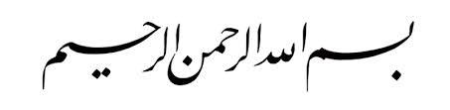

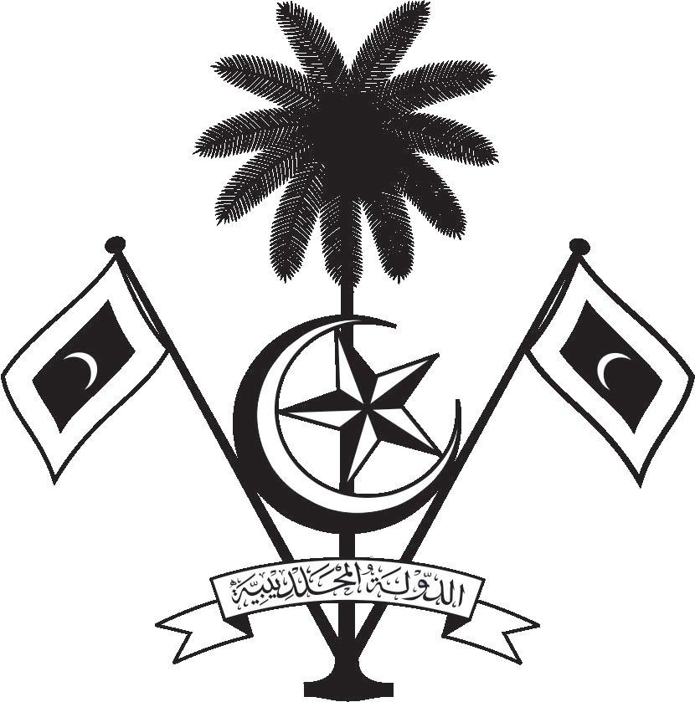

އ.ދ.ގެ ޖެނީވާ އޮފީހާއި ޖެނީވާގައި ހުންނަ ބައިނަލްއަޤްވާމީ ޖަމިއްޔާތަކަށް ކަނޑައަޅާފައިވާ ދިވެހިރާއްޖޭގެ ދާއިމީ މިޝަން
PERMANENT MISSION OF THE REPUBLIC OF MALDIVES TO THE UNITED NATIONS OFFICE
AND OTHER INTERNATIONAL ORGANISATIONS AT GENEVA

36th Session of the Working Group of the Universal Periodic Review

Review of Sao Tome and Principe
27 January 2021

Statement by:
Hawla Ahmed Didi – Deputy Permanent Representative
Check against delivery
Thank you, Madam. President,

The Maldives extends a warm welcome to the high-level delegation of Sao Tome and Principe to this third cycle review and thank them for their presentation today.

The Maldives commends the Government of Sao Tome and Principe for its commitment in addressing the impacts of climate change through its efforts to implement adaptation and mitigation projects. We welcome the adoption of the National Child Protection Policy and its action plan, which aims to define the framework of organized and concerted actions for the prevention of all forms of violence against children and the reduction of its various manifestations.

In constructive spirit, the Maldives presents the following two recommendations to Sao Tome and Principe:

1. To strengthen its efforts to improve and ensure equal access to quality education for all children.
2. To strengthen its efforts to raise awareness on child labour.

We wish our fellow Small Island Developing State, Sao Tome and Principe every success at this review.

Thank you, Madam. President.

