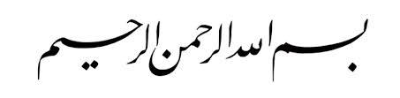

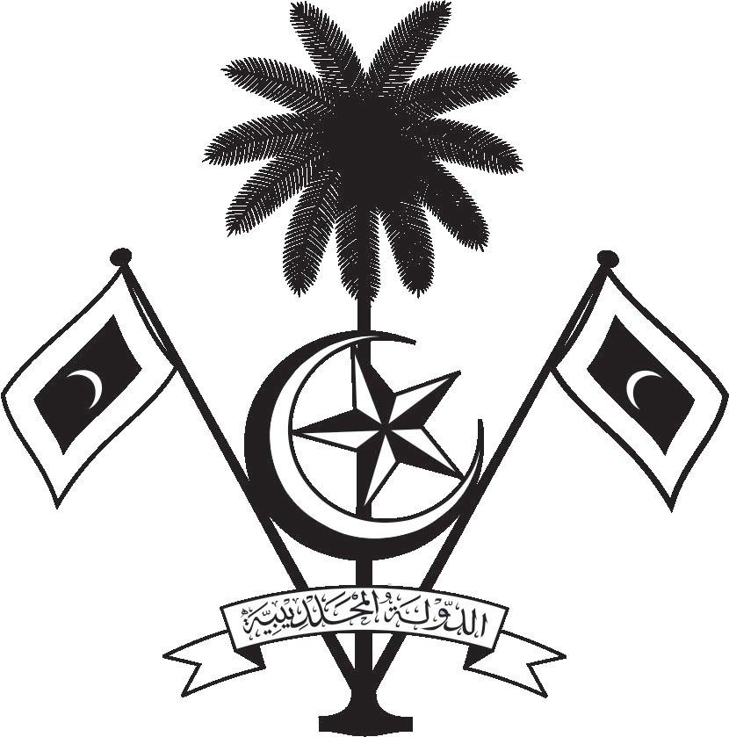

އ.ދ.ގެ ޖެނީވާ އޮފީހާއި ޖެނީވާގައި ހުންނަ ބައިނަލްއަޤްވާމީ ޖަމިއްޔާތަކަށް ކަނޑައަޅާފައިވާ ދިވެހިރާއްޖޭގެ ދާއިމީ މިޝަން
PERMANENT MISSION OF THE REPUBLIC OF MALDIVES TO THE UNITED NATIONS OFFICE
AND OTHER INTERNATIONAL ORGANISATIONS AT GENEVA
37th Session of the Working Group of the Universal Periodic Review
18-29 January 2021, Geneva

Review of Mauritania
19 January 2021

Statement by:

Check against delivery
Thank you, Madam President,

The Maldives warmly welcomes the high-level delegation from the Islamic Republic of Mauritania to this third cycle review and thanks the delegation for their presentation today.

Maldives acknowledges the noteworthy efforts made by the Government of Mauritania to advance human rights in the domestic sphere. We further commend the progress made by the Government of Mauritania since the last UPR cycle, including the constitutional reform carried out in 2017 to increase the number of elected representatives and create several new councils. We also welcome the efforts made by the Government of Mauritania to improve prison conditions by increasing the budget and the health and hygiene conditions in prisons.

In constructive spirit, the Maldives presents the following two recommendations to Mauritania:

- Investigate cases of violence against women and girls, in the private and public spheres, and prosecute those responsible.
- Continue to implement the National Solidarity and the Pandemic Response Plan to limit the impact of the COVID-19 pandemic on the vulnerable population

We wish Mauritania every success at this Review. Thank you, Madam. President.

