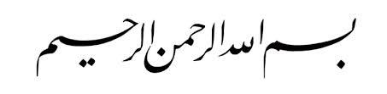

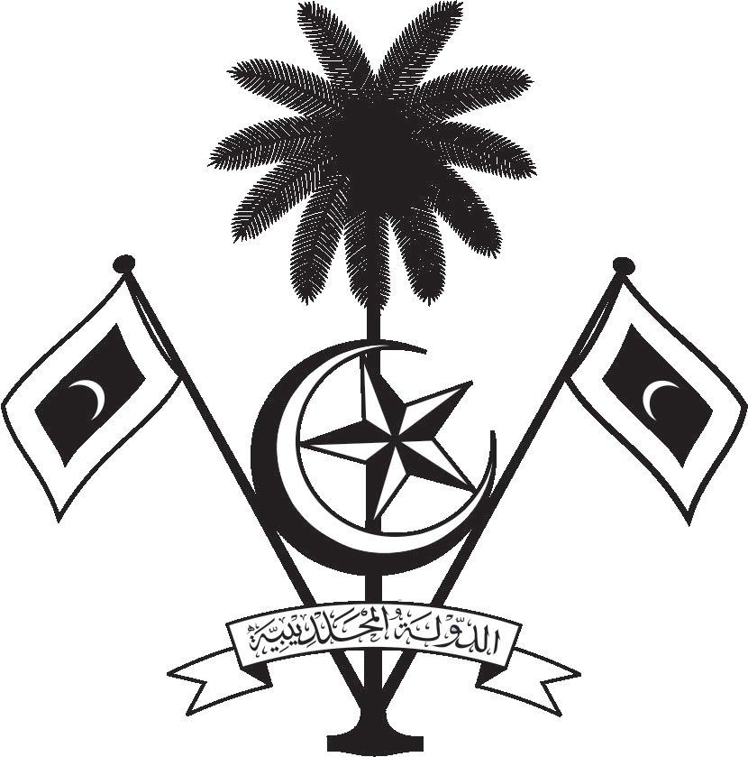

އ.ދ.ގެ ޖެނީވާ އޮފީހާއި ޖެނީވާގައި ހުންނަ ބައިނަލްއަޤްވާމީ ޖަމިއްޔާތަކަށް ކަނޑައަޅާފައިވާ ދިވެހިރާއްޖޭގެ ދާއިމީ މިޝަން
PERMANENT MISSION OF THE REPUBLIC OF MALDIVES TO THE UNITED NATIONS OFFICE
AND OTHER INTERNATIONAL ORGANISATIONS AT GENEVA

37th Session of the Working Group of the Universal Periodic Review
Review of Georgia
26 January 2021
Statement by:

Check against delivery
Thank you, Madam. President,

The Maldives extends a warm welcome to the high-level delegation of Georgia to the Third Cycle Review and thanks them for their presentation today.

The Maldives is encouraged by the establishment of the Office of the State Inspector, reflecting the Government’s will to address the issue of human rights abuses committed by State institutions. We also welcome the mid-term report submitted by Georgia on the implementation status of the recommendations accepted by the State at their second cycle review.

In constructive spirit, the Maldives presents the following recommendations to Georgia:
- Strengthen its efforts to combat gender-based violence, including domestic violence.
- Continue and strengthen its effort to focus on the rights of persons with disabilities.

My delegation wishes Georgia every success at this third cycle review.

Thank you, Madam. President.

