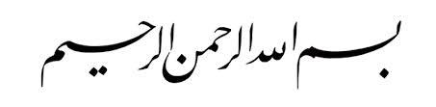

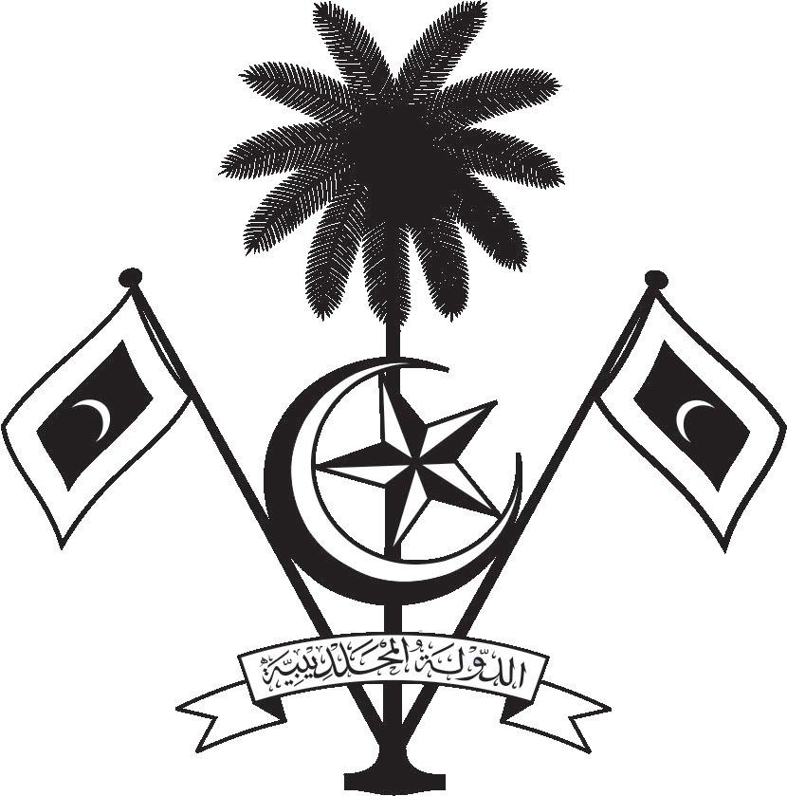

އ.ދ.ގެ ޖެނީވާ އޮފީހާއި ޖެނީވާގައި ހުންނަ ބައިނަލްއަޤްވާމީ ޖަމިއްޔާތަކަށް ކަނޑައަޅާފައިވާ ދިވެހިރާއްޖޭގެ ދާއިމީ މިޝަން
PERMANENT MISSION OF THE REPUBLIC OF MALDIVES TO THE UNITED NATIONS OFFICE
AND OTHER INTERNATIONAL ORGANISATIONS AT GENEVA

37th Session of the Working Group of the Universal Periodic Review
Review of Austria
22 January 2021
Statement by:

Check against delivery
Thank you, Madam President,

The Maldives extends a warm welcome to the high-level delegation of Austria to the UPR process and thanks them for their presentation today.

The Maldives notes the efforts made by Austria to reduce child poverty and welcomes the Government of Austria on the formulation of the National Strategy to Prevent Poverty. We also commend the strategic interventions made to improve representation of women in leadership positions as well as to strengthen women’s participation in the political sphere.

In constructive spirit, the Maldives presents the following two recommendations to Austria:
1. Promote the principle of equal pay for work of equal value and minimize the gender pay gap.
2. To strengthen efforts to access quality education for all children regardless of their socioeconomic status.

My delegation wishes Austria every success at this third cycle review.

Thank you, Madam. President.

