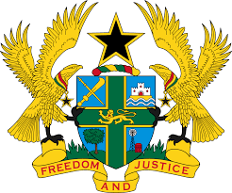

STATEMENT BY GHANA DELIVERED BY H.E RAMSES JOSEPH CLELAND, AMBASSADOR AND PERMANENT REPRESENTATIVE,
WEDNESDAY 27TH JANUARY 2021

REVIEW OF SÃO TOMÉ AND PRÍNCIPE

Thank you, Madam President.

Ghana welcomes the delegation of São Tomé and Príncipe to the UPR Working Group.

My delegation commends São Tomé and Príncipe for adopting a number of domestic legislations and action plans since the second UPR to promote and protect human rights. We note in particular the establishment of a multi-sectoral national committee to coordinate implementation of the child protection policy, created through a national decree entered into force in May 2018.
We further note with appreciation the ratification by São Tomé and Príncipe of the United Nations Convention Against Torture and other Cruel, Inhumane or Degrading Treatment or Punishment (UNCAT).
To further strengthen the promotion and protection of human rights in São Tomé and Príncipe, Ghana recommends the following:
- Consider introducing access to information law in accordance with international standards and practices;
- Consider addressing the root cause of youth unemployment in the country, by providing operational management of policies and programmes for the youth and finally;
- Reinforce relevant measures to address high prevalence of child abuse and domestic violence and ensuring all perpetrators are prosecuted and punished.

My delegation wishes São Tomé and Príncipe every success with the UPR.
I thank you.

