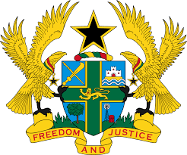

STATEMENT BY GHANA DELIVERED BY H.E RAMSES JOSEPH CLELAND, AMBASSADOR AND PERMANENT REPRESENTATIVE,
WEDNESDAY 27TH JANUARY 2021

REVIEW OF SAINT KITTS AND NEVIS

Thank you, Madam President.

Ghana warmly welcomes the delegation of Saint Kitts and Nevis to the UPR Working Group.
We commend the government for the commitment to considerable progress in promoting, protecting and respecting human rights in the country through the introduction of a number of initiatives aimed at improving the standard of living for its citizens. Notable is the Poverty Alleviation Programme (PAP) launched in 2018 to provide financial support to low-income households. We further take note of the implementation of the National Social Protection Strategy and Action Plan and the launch of the Education Sector Plan (2017-2021).
My delegation also applauds Saint Kitts and Nevis for the recent ratification of the United Nations Convention Against Torture and other Cruel, Inhumane or Degrading Treatment or Punishment (UNCAT). Ghana wishes to know what actions the government has planned to implement the convention and what further support it needs towards this objective.
To further strengthen human rights promotion and protection in Saint Kitts and Nevis my delegation wishes to make the following recommendations:

- Consider enacting a comprehensive legislation that provides full and effective protection against discrimination in all forms, and which contains a comprehensive list of prohibited grounds of discrimination and;
- Take steps to ensure the empowerment of women in the country by ensuring that women are well represented in decision-making positions and in political bodies, particularly in parliament.

My delegation wishes Saint Kitts and Nevis every success with the UPR.
I thank you.

