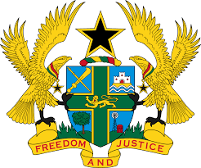

STATEMENT DELIVERED BY MR. FRANCIS D. KOTIA,
DEPUTY PERMANENT REPRESENTATIVE, ON BEHALF OF GHANA AT THE 37TH SESSION OF THE HUMAN RIGHTS COUNCIL
WEDNESDAY, 20TH JANUARY, 2021

REVIEW OF RWANDA

Thank you, Madam President.

Ghana welcomes Rwanda to the UPR Working Group.
My delegation commends the Rwandan government for its commitment to promoting, protecting and respecting human rights in the country through the holding of a referendum and revision of the constitution which dedicated an entire chapter on human rights and freedom. We also take note, with admiration, the increase in women’s representation in higher decision-making positions.
Ghana’s delegation makes the following recommendations:

- Intensify its efforts to ensure full enjoyment of the right to freedom of expression, peaceful assembly and association;
- Ensure that the right to freedom of religion or belief is guaranteed and
protected within Rwanda, and that religious minorities are treated equally as regards their human rights and fundamental freedoms;

Our delegation wishes Rwanda a successful UPR outcome.
I thank you.

