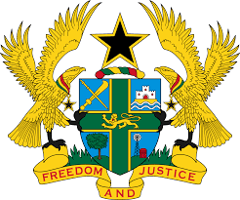

STATEMENT DELIVERED BY H.E RAMSES JOSEPH CLELAND,
AMBASSADOR AND PERMANENT REPRESENTATIVE, ON BEHALF OF GHANA AT THE 37TH SESSION OF THE HUMAN RIGHTS COUNCIL
THURSDAY, 21ST JANUARY, 2021

REVIEW OF OMAN
Thank you, Madam President
Ghana welcomes Oman to the UPR Working Group.
My delegation commends the establishment of a number of laws and decrees which protect and promote human rights in the country.
Whilst congratulating Oman on the recent ratification of UNCAT, Ghana wishes to know what actions are planned to implement the Convention and what additional support is needed.
Ghana further wishes to recommend to Oman to:
- ensure access to justice for all, in particular the vulnerable and minority groups, including women and migrant workers; and urges Oman to
- Pursue efforts in the promotion and of empowerment of women in the country by ensuring full and equal participation of women in political and public life and in decision-making at the local and national levels and lastly;
- Continue to strengthen efforts to prevent and combat the abuse of migrant domestic workers in the country by ensuring full implementation of international and domestic laws.

Ghana wishes Oman every success with the UPR process.

I thank you.

