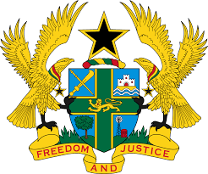

STATEMENT DELIVERED BY H.E RAMSES JOSEPH CLELAND,
AMBASSADOR AND PERMANENT REPRESENTATIVE, ON BEHALF OF GHANA AT THE 37TH SESSION OF THE HUMAN RIGHTS COUNCIL
MONDAY, 25TH JANUARY, 2021

REVIEW OF MYANMAR

Thank you, Madam President.
Ghana welcomes the delegation of Myanmar to the UPR Working Group.
We commend the steps taken by the Government, since the last UPR to promote and protect human rights, such as the implementation of the National Case Management Programme (NCMP) in all courts and the signing of the MoU for implementation of Myanmar Decent Work Country Programme (2018-2021).

Ghana wishes to know whether the Government has a time frame for ratifying outstanding international treaties and conventions, especially UNCAT.
We further Urge the Government to consider undertaking constitutional reforms to improve, among others, the security and judicial services; and to continue to enact and fully implement legislations that seek to promote and protect the rights to freedom of expression and religion.

We wish Myanmar every success with the UPR process.

I thank you.

